XFGS-3800 Series
L2+ Managed GbE Fiber Aggregation Switches
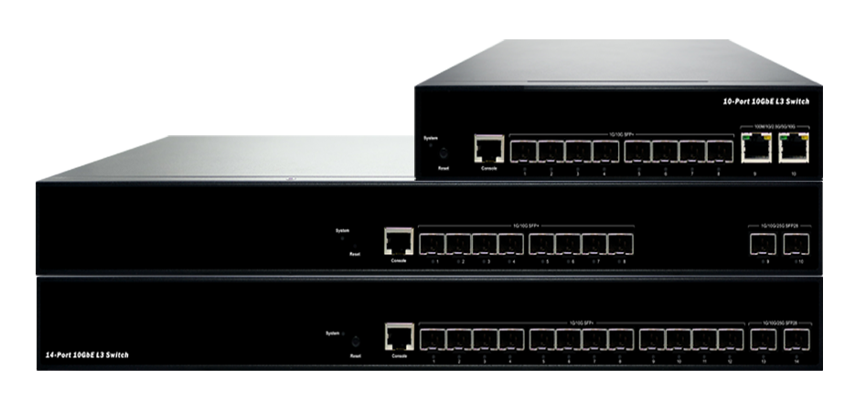
XFGS-3810A
XFGS-3810YA
XFGS-3810YA
Overview
XFGS-3800 Series L2+ Managed GbE Fiber Switches are next-generation managed (1G/10G) SFP+ fiber and (1G/10G/25G) SFP28 Multi-Gigabit aggregation switch offering powerful L2 and basic L3 features with better functionality and usability.
XFGS-3800 Series delivers 8/12 (1G/10G) Multi-Gig SFP+ or 2 (1G/10G/25G) SFP28 ports or 2 (100M/1G/2.5G/5G/10G) RJ45 ports and RJ45 Console port. XFGS-3800 Series provides high HW performance for aggregation/access network applications.
Key Features
- Fully L2 features provide easier manageability, security and QoS
- IEEE 1588v2 PTP
- ITU-T G.8031 Ethernet Linear Protection Switching (EPS)
- ITU-T G.8032 Ethernet Ring Protection Switching (ERPS)
- DHCP Server
- IPv4/IPv6 L3 static route
- RIP v1/v2 L3 dynamic routing
- OSPFv2/v3 L3 dynamic routing

Benefits
- Feature-Rich Ethernet Switch for High Bandwidth Aggregation Applications
This Multi-Gigabit switch delivers advanced functionality including L2 and L3 switch features. It also has enhanced security features such as IP source guard, Access Control List to guard your network from unwanted or unauthorized access.
It helps users to build on the market-leading price/performance with this Multi-Gig Ethernet switch, and provides secure, reliable for aggregation network deployments.
Specifications
Port Configuration
Model name | Total Ports | SFP+ (1G/10G) | SFP28  (1G/10G/25G) | RJ45 (100M/1G/2.5G/5G/10G) | Console
XFGS-3810A | 10 | 8 | -- | 2 | RJ45
XFGS-3810YA | 10 | 8 | 2 | -- | RJ45
XFGS-3814YA | 14 | 12 | 2 | -- | RJ45
Note: USB Console is optional by request

Hardware Performance
Model name | Forwarding Capacity (Mpps) | Switching Capacity  (Gbps) | Mac Table  (K) | Jumbo Frames  (Bytes)
XFGS-3810A | 148.809 | 200 | 32 | 10K
XFGS-3810YA | 193.44 | 260 | 32 | 10K
XFGS-3814YA | 252.876 | 340 | 32 | 10K

Environmental Range
Operating Temperature | Storage Temperature | Altitude
0°C to 50°C | -20 to 70°C | < 3000m

Dimension, Weights, Humidity
Model name | Dimension (WxHxD) | Weight | Operating Humidity
Model name | Millimeter | Kilograms | Operating Humidity
XFGS-3810A | 220 x 44 x 243 | TBD | Up to 95%, non-condensing
XFGS-3810YA | 442 x 44 x 211 | TBD | Up to 95%, non-condensing
XFGS-3814YA | 442 x 44 x 300 | TBD | Up to 95%, non-condensing

Power Supply / Voltage and Frequency
Model name | AC Input Voltage and Frequency
XFGS-3810A | Fixed single PSU / 100-240 VAC, 50~60 Hz
XFGS-3810YA | Hot-Swappable Dual AC PSUs / 100-240 VAC, 50~60 Hz
XFGS-3814YA | Hot-Swappable Dual AC PSUs / 100-240 VAC, 50~60 Hz

Compliance
EMC and Safety
- SHALL comply with European Directives for CE marking (LVD with EN 62368-1)
- SHALL comply with FCC Part 15 Class A
- Other by Request

Software Features
Layer 2 Switching
Spanning Tree Protocol (STP) | - Standard Spanning Tree 802.1d  - Rapid Spanning Tree (RSTP) 802.1w  - Multiple Spanning Tree (MSTP) 802.1s
Trunking | Link Aggregation Control Protocol (LACP) IEEE 802.3ad
VLAN | Supports up to 4K VLANs simultaneously (out of 4096 VLAN IDs)  - Port-based VLAN  - 802.1Q tag-based VLAN  - MAC-based VLAN  - Management VLAN  - Private VLAN Edge (PVE)  - Q-in-Q (double tag) VLAN  - Voice VLAN  - GARP VLAN Registration Protocol (GVRP)
DHCP Relay | - Relay of DHCP traffic to DHCP server in different VLAN.  - Works with DHCP Option 82
IGMP v1/v2/v3 Snooping | IGMP limits bandwidth-intensive multicast traffic to only the requesters. Supports 1024 multicast groups
IGMP Querier | IGMP querier is used to support a Layer 2 multicast domain of snooping switches in the absence of a multicast router
IGMP Proxy | IGMP snooping with proxy reporting or report suppression actively filters IGMP packets in order to reduce load on the multicast router
MLD v1/v2 Snooping | Delivers IPv6 multicast packets only to the required receivers
Layer 3 Switching
IPv4 Static routing | IPv4 Unicast: Static routing
IPv6 Static routing | IPv6 Unicast: Static routing
RIP v1/v2 | Routing Information Protocol (RIP) protocol are the intra-domain (interior) routing protocol which is based on distance vector routing and it is used inside an autonomous system.
OSPF v2/v3 | OSPF is a link-state routing protocol. It is designed to be run internal to a single Autonomous System. Each OSPF router maintains an identical database describing the Autonomous System's topology. From this database, a routing table is calculated by constructing a shortest-path tree.
Security
Secure Shell (SSH) | SSH secures Telnet traffic in or out of the switch, SSH v1 and v2 are supported
Secure Sockets Layer (SSL) | SSL encrypts the http traffic, allowing advanced secure access to the browser-based management GUI in the switch
IEEE 802.1X | - IEEE802.1X: RADIUS authentication, authorization and accounting, MD5 hash, guest VLAN, single/multiple host mode and single/multiple sessions  - Supports IGMP-RADIUS based 802.1X  - Dynamic VLAN assignment
Layer 2 Isolation Private VLAN Edge | PVE (also known as protected ports) provides L2 isolation between clients in the same VLAN. Supports multiple uplinks
Port Security | Locks MAC addresses to ports, and limits the number of learned MAC address
IP Source Guard | Prevents illegal IP address from accessing to specific port in the switch
RADIUS/ TACACS+ | Supports RADIUS and TACACS+ authentication. Switch as a client
Storm Control | Prevents traffic on a LAN from being disrupted by a broadcast, multicast, or unicast storm on a port
DHCP Snooping | A feature acts as a firewall between untrusted hosts and trusted DHCP servers
ACLs | Supports up to 256 entries. Drop or rate limitation based on:  - Source and destination MAC, VLAN ID or IP address, protocol, port,  - Differentiated services code point (DSCP) / IP precedence  - TCP/ UDP source and destination ports  - 802.1p priority  - Ethernet type  - Internet Control Message Protocol (ICMP) packets  - TCP flag
Quality of Service
Hardware Queue | Supports 8 hardware queues
Scheduling | - Strict priority and weighted round-robin (WRR)  - Queue assignment based on DSCP and class of service
Classification | - Port based  - 802.1p VLAN priority based  - IPv4/IPv6 precedence / DSCP based  - Differentiated Services (DiffServ)  - Classification and re-marking ACLs
Rate Limiting | - Ingress policer  - Egress shaping and rate control  - Per port
Management
DHCP Server | Support DHCP server to assign IP to DHCP clients
Remote Monitoring (RMON) | Embedded RMON agent supports RMON groups 1,2,3,9 (history, statistics, alarms, and events) for enhanced traffic management, monitoring and analysis
Port Mirroring | Traffic on a port can be mirrored to another port for analysis with a network analyzer or RMON probe. Up to N-1 (N is Switch’s Ports) ports can be mirrored to single destination port. A single session is supported.
UPnP | The Universal Plug and Play Forum, an industry group of companies working to enable device-to-device interoperability by promoting Universal Plug and Play
s-Flow | The industry standard for monitoring high speed switched networks. It gives complete visibility into the use of networks enabling performance optimization, accounting/billing for usage, and defense against security threats
IEEE 802.1ab (LLDP) | - Used by network devices for advertising their identities, capabilities, and neighbors on an IEEE 802ab local area network  - Support LLDP-MED extensions
Web GUI Interface | Built-in switch configuration utility for browser-based device configuration
CLI | For users to configure/manage switches in command line modes
Dual Image | Independent primary and secondary images for backup while upgrading
SNMP | SNMP version1, 2c and 3 with support for traps, and SNMP version 3 user-based security model (USM)
Firmware Upgrade | - Web browser upgrade (HTTP/ HTTPs) and TFTP  - Upgrade through console port as well
Other Management | - HTTP/HTTPs; SSH  - DHCP Client/ DHCPv6 Client  - Cable Diagnostics  - Ping  - Syslog  - Telnet  - IPv6 Management
Synchronization
IEEE 1588v2 PTP | Support IEEE 1588 v2 PTP (Precision Time Protocol)
NTP | Network Time Protocol (NTP) is a networking protocol for clock synchronization between computer systems over packet-switched
Loop Protection
ITU-T G.8031 | Supports ITU-T G.8031 Ethernet Linear Protection Switching
ITU-T G.8032 | Supports ITU-T G.8032 Ethernet Ring Protection Switching
Loop Detection | Supports Loop Detection and Protection

